1. **Agenda:**
   1. Our Singleton is thread-safe.
2. 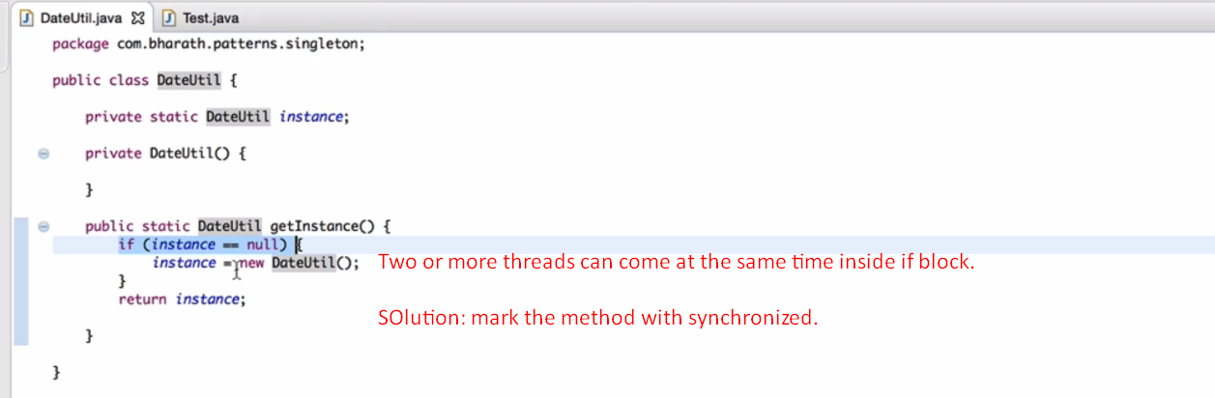
3. 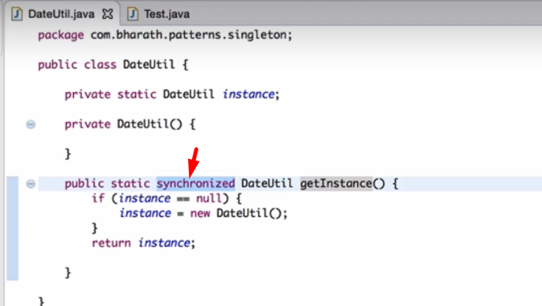
4. 